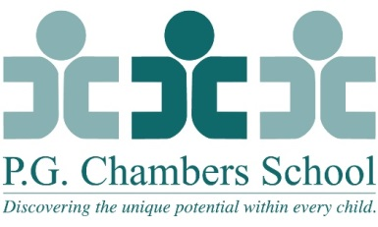
Speech Language Pathologist: Full-Time and/or Part-Time
P.G. Chambers School, a private school for children with multiple disabilities, seeks a part-time and/or full-time Speech Language Pathologist. Candidates should have at least one year experience in a school setting, with skills in team collaboration, augmentative communication, and feeding. Competitive salary. NJ Speech Language Pathology License, School Certification, and Certificate of Clinical Competence required. Please email resume and cover letter. P.G. Chambers School is an equal opportunity employer.
Scope of Responsibilities:
- Administers direct speech and language, feeding and augmentative services to children following the School’s interdisciplinary, family centered philosophy.
- Provides services on-site, as well as, in homes and various community settings.
- Utilizes treatment techniques which follow an NDT, SI, Developmental and/or Functional framework.
- Provides professional assessment of each child’s strengths, needs and accomplishments.
- Develops an individual program plan for each child which incorporates the assessment findings with the goals and objectives of the child and family. Communicates this plan verbally and in writing to the family and interested parties.
- Coordinates services with the child’s family, school and other agencies as needed.
- Participates in the development and implementation of new programs and services. Prepares, maintains and transmits accurate written and oral reports for each child following the Department’s guidelines.
- Invests in professional growth by attending meetings, conferences, and continuing education programs.
- Adapts and fabricates equipment to meet the needs of each child.
- Physically handles and lifts children within the context of therapy sessions.
- Provides instruction and supervision for Speech and Language Pathology Students and supportive personnel.
- Acts as Program Manager for assigned clients.
- Performs other duties as requested.
- Maintains current and appropriate materials including therapy supplies and assessment instruments.
Qualifications:
- Master’s Degree in Speech and Language Pathology
- Certificate of Clinical Competence
- New Jersey State Department of Education Speech Language Specialist
- New Jersey State Licensure
- One year related experience preferred.
- Physical ability to lift 40 lbs.

